**HOME :**

POWER SYSTEM SERVICES IS ONE OF THE LEADING NAME for SIEMENS MAKE ELECTRICAL EQUIPMENS AND ITS SPARES FOR **SALES, SERVICES AND STOCKIEST:**

* **HT High Voltage Panels WITH RANGE FROM 11KV to 33KV,**
* **ONE TO ONE REPLACEMENT, RETROFITTING of VCBs & ACBs, RMUs for small industries like Hotels,Malls,Theaters, and Building Apartment, etc.**
* **EHV BREAKER  (Sf6 Gas CB) WITH RANGE FROM 66KV to 765KV,**
* **Isolators from 33KV to 765KV,**

PHOTO OF AUTHO CERTI FOR MV

PHOTO OF AUTHO CERTI FOR HV

**“WE ARE ENLIGHTENING INDUSTIES WITH LIGHTING AND SMILE OF CUSTOMER.”**

**ABOUT US :**

WE POWER SYSTEM SERVICES STARTED BUSINESS IN 2006 AND HAVE BEEN SERVING INDUSTRY AND UTILITY SECTORS UPTO BEST OF OUR CAPABILITIES. WE POWER SYSTEM SERVISES RUNNING BUSINESS WITH MINUMUM EXPERT MAXIMUM EXPERTISE. WE PROPER UNDERSTAND THE REQUIREMENTS OF OUR EACH CLIENTS, INDENTIFY THE PROBLEMS AND IMPLIMENT THE CORRECT SOLUTION FOR OUR CLIENTS.

**STRENGTH :** OUR MEJOR STRENGH IS OUR STOCK TO FACE THE EMERGENCY AT SITE DURING FLESHOVER OR PLANT SHUTDOWN ETC. WE PROUD TO DECLARE THAT WE ARE THE ONLY ONE IN ENTIRE INDIA WHO KEEPS HUGE STOCKS OF SPARES FOR SIEMENS MAKE OLD AND NEW DESIGN VCBs AS WELL AS SF6 CIRCUIT BREAKERS,ISOLATORS ETC.WE ALSO KEEP STOCKS OF SIEMENS MAKE SPARES OF HT PANELS ,VCBs, IN RANGE FROM **11KV to 33KV, EHV SF6 CIRCUIT BREAKRS IN** RANGE FROM **72.5KV TO 420KV & DISCONNECTOR/ISOLATORS OF SIEMENS/ELPRO MAKE IN RANGE FROM 72.5KV TO 420KV WE ALSO DEAL IN DESIGNED, MANUFACTURING AND SUPPLY OF SIEMENS MAKE AS WELL AS SYSTEM HOUSE MAKE HT PANELS AS PER CLIENT REQUIREMENTS.WE HAVE ENOUH EXPERT TEAM FOR RETROFITTING OF VCBs,VACUUM CONTACTORS LIKE ONE TO ONE REPLACEMENT AND CASSET TYPE REPLACEMENT. WE PROVIDE SIEMENS MAKE SUCH RETROFITTING SOLUTION THAT EXISTING VCB CAN BE USED AT SAME TIME WITH NEW RETROFITTED VCBs. WE HAVE ISOLATOR UPGRADATION SOLUTION WITH NEW DESING SPARES TO RESOLVE THE HOTSPOT ISSUES AT SITE.**

**OUR EXPERIENCE :** WE HAVE RETROFITTED MORE THEN 1500 BREAKES DURING OUR JOURNEY FROM 2006 WHICH IS CONSIDERABLE HIGH FIGURS IN RETROFITTING BUSINESS. WE HAVE COMLETED MORE THAN 20,000 HEALTH CHECKUP JOBS OF BREAKERS WITH PANEL UNDER GUIDELINE FROM SIEMENS LTD. POWER SYSTEM SERVICES GIVING PROER TRAINNING TO THEIR STAFF IN SIEMENS WORK SHOP AND KEEP THEM UP TO DATE FOR NEW PRODUCTS. POWER SYSTEM SERVICES ALSO GIVING PERIODICALLY TRAINNIING FOR SAFTY THRU GOVT. AUTORISED SAFTY INSPECTOR. WE HAVE AVAILABE ALL THE BRANDED TESTING EQUIPMENS LIKE CONTACT RESISTANCE TEST KIT, MEGGER FOR IR VALUE, HI-POT TESTING KIT AND MANY MORE WHICH ARE CALIBRATED PERIODICALLY. WE POWER SYSTEM SERVICES ADDRESS THE INQUIRIES WITH ECONOMICAL SOLUTION TO CUSTOMERS INSTEAD OF GETTING ONLY BUSINESS.

**CLIENT :**

**POWER GRID CORPORATION OF INDIA LTD.**

**AMUL LTD.**

**GSPC LNG LTD.**

**GSEG**

**GSECL-SIKKA UNIT / KLTPS / UKAI UNIT / DHUVARAN UNIT/WANAKBORI UNIT**

**IFFCO-KANDLA UNIT**

**AM/NS ARCELOR MITTAL/NIPPON STEEL – HAZIRA UNIT/MP UNIT**

**IOCL- GUJARAT REFINERY**



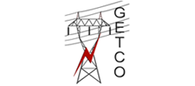

  


  
  
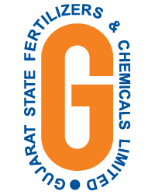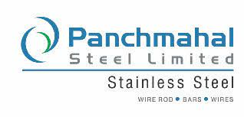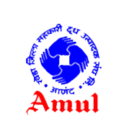



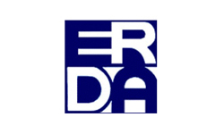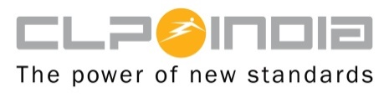



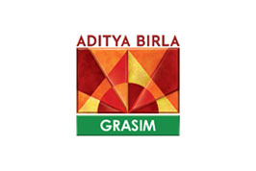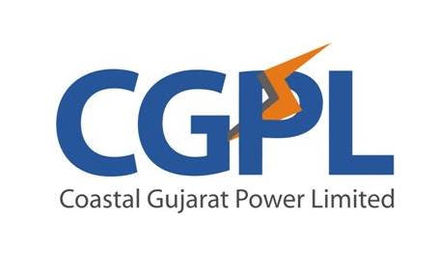



 

**ONGC** 